**What is Programming ?**

* Programming is the process of writing code to facilitate specific actions in a computer, application or software program that instructs computer to perform a task.
* Some of the programming languages are C, C++, Java, Python, etc…

**What is python ?**

Python is a widely used general-purpose, high level programming language.

* It was initially designed by **Guido van Rossum** in **1991** and developed by **Python Software Foundation.**
* Python runs faster and integrates systems more efficiently.
* There are **two** major Python versions- Python 2 and Python 3.

**Features of Python:**

* **Easy to Code:** It is a very developer-friendly language.
* **Open Source and Free:** Anyone can create and contribute to its development. It is free to download.
* **Support for GUI:** It supports wide array of GUIs which can easily be imported to the interpreter.
* **Object-Oriented Approach:** Python recognizes the concept of class and object encapsulation.
* **Highly Portable:**  It can run on any Operating System.
* **Highly Dynamic:** Specifying variable type is not required.
* **Interpreted Language:** It executes the code line by line.
* **Large Standard Library:** Python supports a large number of inbuilt libraries which makes programming simpler and convenient.

**Installation of Python:**

* Python software can be installed from <http://python.org/downloads/>
* It can run on many freely available interpreters like IDLE (Integrated Development Environment).
* **Steps to follow:**

Step 1: Select Version of Python to Install.

Step 2: Download Python Executable Installer.

Step 3: Run Executable Installer.

Step 4: Verify Python Was Installed On Windows.

Step 5: Verify Pip Was Installed.

Step 6: Add Python Path to Environment Variables (Optional)

**Print() statement:**

* It prints the message to the screen.
* Return Type: It returns the output to the screen
* **Syntax:** print(value)

print(value(s), sep= ' ', end = '\n')

* **Parameters:** 
  1. value(s) : Any type and no. of values can be converted to string before printing.
  2. sep = ’separator’ : Separates the objects.
  3. end: (Optional) Specify what to print at the end.
* print() function requires an empty parenthesis at the end.

**String Literals:**

* It defines how a specific string appears when printed.

**\n :** Used to add a new blank line while printing a statement.

**“ ” :** Used to print an empty line.

**Example:** print("My name is : \n Python")

**Output:**  My name is :

Python

* **end= ” ” statement:**

Specifies the content to be printed at the end.

**Example:** Python print() without new line:

print(“Hello Students ! ”,end=”\t”)

print(“Welcome to Python Course”)

**Output:** Hello Students ! Welcome to Python Course

* **Separator:**

To separate multiple arguments in print( ) function, “sep” keyword is used.

**Example:** a ,b ,c =26 ,08 ,2022

print(a ,b ,c ,sep = "-" )

**Output:** 26-08-2022

* print("Hello", "how are you?")

Output : Hello how are you?

* x = ("apple", "banana", "cherry")

print(x)

Output : ('apple', 'banana', 'cherry')

* x = 10

print(x)

Output: 10

* y = input(“Enter your name :”) #(Consider input as ‘Jake’)

print(“Your name is ”,y)

Output : Your name is Jake

**Python Variables:**

* Variables are reserved memory locations to store values.
* Interpreter allocates memory and decides what can be stored in it based on the data type of a variable. Integers, decimals or characters values can be stored by assigning different data types to variables.

**Rules for Python variables:**

* Starts with a letter(case sensitive) or the underscore character.
* Cannot start with a number.
* Contains alphanumeric characters and underscores (A-Z, a-z, 0-9, and _ )

**or**

Here are naming conventions for Python identifiers:

* Class names start with an **UPPERCASE** letter. All other identifiers start with a **lowercase** letter(Alphabets).
* Starting an identifier with a single leading underscore indicates that the identifier is private.
* Starting an identifier with two leading underscores indicates a strongly private identifier.
* If the identifier also ends with two trailing underscores, the **identifier is a language - defined special name**.

**Examples:**

These Work:

X, x, _WheresThePartyTonight,Bond007

And these Don’t:

007Bond, _WheresThePartyTonight?

1)9Name=10

print(9Name)

#1)variable name can not start with numbers

Name9=10

print(Name9)

2)#python is case sensitive

age9=10

print(age9)

3)age 9=10

print(age 9)

4)age$9=10

print(age$9)

**Declaration and Initialization:**

* Python variables do not need explicit declaration.
* The declaration happens automatically when value is assigned.
* The equal sign (=) is used to assign values to variables.
* Ex: a = 10 (Here, 10 is stored in variable ‘a’)

**Multiple Assignment:**

* a = b = c = 1 (Here, an integer object is created with the value 1, and all three variables are assigned to the same memory location. )

**Some Examples:**

* a,b,c = 1, 2 , ”letter”

Variable ‘a’ stores integer value ‘1’.

Variable ‘b’ stores integer value ‘2’.

Variable ‘c’ stores the string ‘letter’.

* a= 100 # An integer assignment

b = 1000.0 # A floating point

c = "John" # A string

print (a)

print (b)

print (c)

**Output:** 100

1000.0

John

**DATA TYPES:**

* Everything is an object in Python programming.
* Data types refers to the classification or categorization of data items.
* Data types are actually classes and variables are instance (object) of these classes.
* Following are the standard or built-in data type of Python:

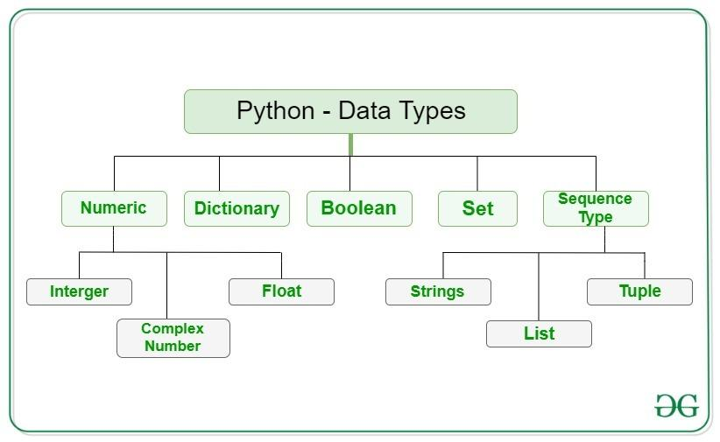

**NUMERIC DATA TYPE:**

Numeric data type represents number values. Numeric data type can be integer, floating number or even complex numbers. These values are defined as int, float and complex class in Python.

* **Integers** – It contains positive or negative whole numbers (without fraction or decimal).
* **Float** – It is a real number with floating point representation. It is specified by a decimal point.
* **Complex Numbers** – It is specified as *(real part) + (imaginary part)j*. For example – 2+3j

**SEQUENCE DATA TYPE:**

It is the ordered collection of similar or different data types. There are several sequence types in Python such as:

**1) String:**

String is a collection of one or more characters put in a quote. In python there is no character data type, a character is a string of length one.

**2) List:**

[Lists](https://www.geeksforgeeks.org/python-list/) are like the arrays. It is an ordered collection of data of same type or different types.

**3) Tuple:**

T[uple](https://www.geeksforgeeks.org/python-tuples/) is an ordered collection of Python objects. The difference between tuple and list is that tuples are immutable.

**BOOLEAN DATA TYPE:**

Data type with one of the two built-in values, True(T) or False(F). It is denoted by the class bool.

**SET DATA TYPE:**

[Set](https://www.geeksforgeeks.org/python-sets/) is an unordered collection that is iterable, mutable and has no duplicate elements. The order of elements in a set is undefined.

**DICTIONARY DATA TYPE:**

[Dictionary](https://www.geeksforgeeks.org/python-dictionary/) is an unordered collection of data values,which **holds key:value pair**.

**COMMENTS**

* Comments are the statements that are not executed by the compiler and interpreter. It can be used to provide information or explanation about the code.
* In python, comments are of two types namely :

1. **Single Line Comment :**

A line beginning with **(#)** symbol is considered as a comment.

1. **Multiline Comments :**

A Multi line comment is used to comment multiple lines together. Triple double quote **(“ “ “)** and single quote **(‘ ‘ ‘)** are used for multi-line commenting.

**Example:**

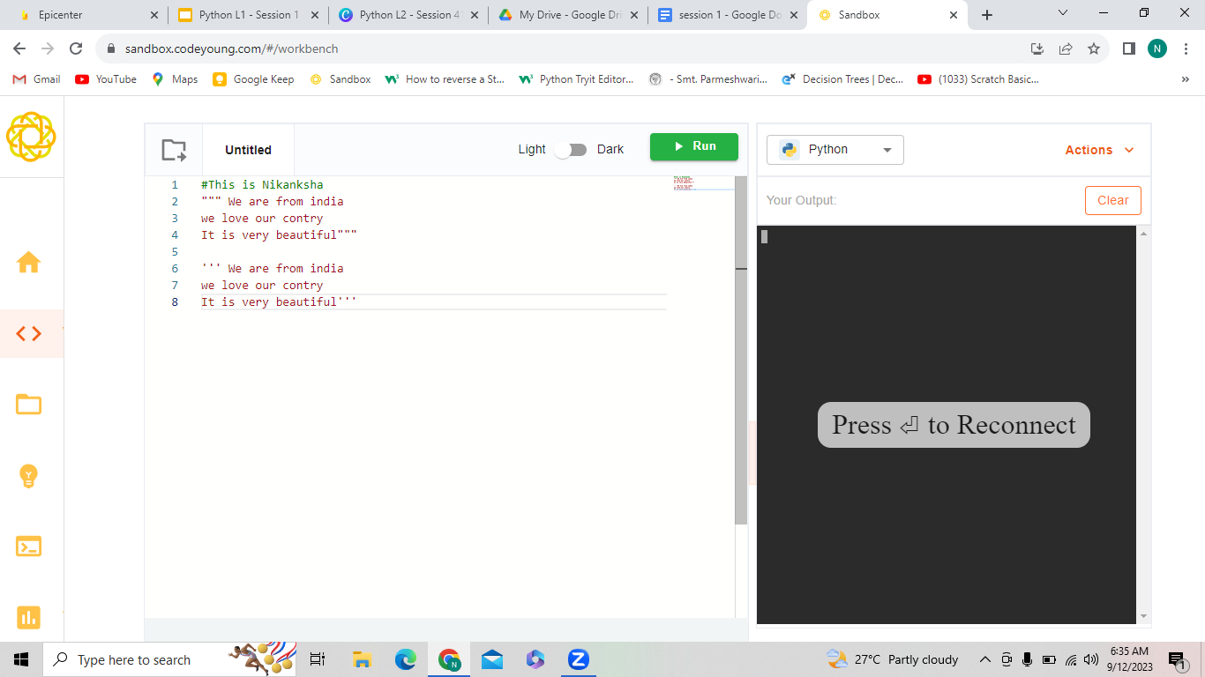

**TYPE CONVERSION:**

* Type conversion is the process of converting the value of one data type (integer, string, float, etc.) to another.
* Python has two types of type conversion:

**1. Implicit Type Conversion:**

* Implicit type conversion automatically converts one data type to another data type without user involvement.

**2. Explicit Type Conversion / Type Cast:**

* Explicit type conversion/typecasting converts one data type to another data type using predefined functions like int(), float(), str(), etc.
* **Syntax:**

<required_datatype>(expression)

**IMPORTANT POINTS IN TYPE CONVERSION:**

1. Type Conversion is the conversion of object from one data type to another data type.
2. Implicit Type Conversion is automatically performed by the Python interpreter.
3. Python avoids the loss of data in Implicit Type Conversion.
4. Explicit Type Conversion is also called Type Casting, the data types of objects are converted using predefined functions by the user.
5. In Type Casting, loss of data may occur as we enforce the object to a specific data type.

**TAKING INPUT FROM USER**

* Python has an input function which is used to take input from the user. It stops the program and wait for the user to key in the data.
* Program resumes once ENTER or RETURN key is pressed.
* A message can also prompt to the user to enter the input.
* **Syntax:** input(prompt)
  + **prompt [optional]:** Any string value to display as input message.
  + **Returns:** Returns a **string value**.
* **Example:**

1. a = input()

- This gets the input without displaying any message

2. name = input(“Enter your name :”)

- This displays the message “Enter your name :” to take

the input from the user.

3. num = int(input(“Enter a number :”))

- This gets the string input from the user and stores it as integer to the variable.

**Homework:**

1. Your school principal wants to print the number of years left for retirement of the staff by collecting their name and age. But he has no idea on how to do that. Help him to create a python program that gets the staff name and age and print the following statement as output - print(name, “ has “,years,” for retiring”). [HINT: Consider the retirement age as 50]
2. It's D-marts 10th Anniversary and is planning for a big give away and in order to choose the lucky draw winner D-mart first needs to collect all of its customer details such as name, phone number, email id and location. On collecting the customer details D-mart even wants to thank each and every customer for visiting as soon as they entered their details. Help the D-mart manager with creating this program.
3. Write a python program to get the user’s name, age and address from the user and print them in separate line.

[HINT : Use input() and print() functions]

4. Write a program to get 2 numbers from user and store them in variables and print them as “Values before swapping” . After that, swap the values in those variables and print the values as “Values after swapping”.

An **Identifier** is a name assigned to an entity in a computer program so that it can be identified distinctly in the program during its execution. On the other hand, a **variable** is a name assigned to a memory location that stores a value. Read this article to learn more about identifiers and variables and how they are different from each other.

## What is an Identifier?

**Identifiers** are used to name a variable, a function, a class, a structure, a union. In other words, an identifier is created to give a unique name to an entity. It can consist of alphabets, digits, and underscores, and can be written in uppercase or lowercase. There is no punctuation or special symbol, except the underscore in the declaration of an identifier.

An identifier can start with lowercase letters, uppercase letters, or an underscore. It helps to locate the name of the entity which is defined along with a keyword.

## What is a Variable?

**Variables** are used to give a name to a memory location that holds a value. Hence, a variable is also an identifier. The names of variables are different which cannot be a keyword. Also, the value stored in a variable can be modified during the execution of the program

Python Lexicon

***Stimulants***

**1. Is Python case sensitive when dealing with identifiers?**

a) yes

b) no

c) machine dependent

d) none of the mentioned

**2. What is the maximum possible length of an identifier?**

a) 31 characters

b) 63 characters

c) 79 characters

d) none of the mentioned

**3.Which of the following is invalid?**

a) _a = 1

b) __a = 1

c) __str__ = 1

d) none of the mentioned

**4. Which of the following is an invalid variable?**

a) my_string_1

b) 1st_string

c) foo

d) _

**5. All keywords in Python are in**

a) lower case

b) UPPER CASE

c) Capitalized

d) None of the mentioned

**7. Which of the following is true for variable names in Python?**

a) unlimited length

b) all private members must have leading and trailing underscores

c) underscore and ampersand are the only two special characters allowed

d) none of the mentioned

**8. Which of the following is an invalid statement?**

a) abc = 1000000

b) a b c = 1000 2000 3000

c) a,b,c = 1000, 2000, 3000

d) a_b_c = 1000000

**9. Which of the following cannot be a variable?**

a) __init__

b) in

c) it

d) on

**10. Who developed Python ?**

A) Ritche

B) Guido Van Rossum

C) Bill Gates

D) Sundar Pichai

**11. Which of the following character is used to give comments in Python Program ?**

A) #

B) &

C) @

D) $

**12. What will be the output of the below code snippet?**

var = 10

print(type(var))

var = "Hello"

print(type(var))

1. str and int
2. int and int
3. str and str
4. int and str

**13. Which of the following is not a data type in Python ?**

1. String
2. Numbers
3. Slice
4. List